June 18 rally Stop cuts
to Crossing Guards

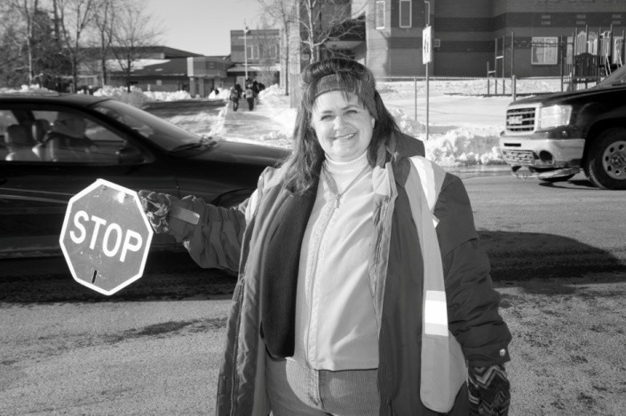

WHEN: Wednesday, June 18 at 4:00 pm

WHERE: CBRM Civic Centre

WHO: CUPE crossing guards and their supporters, school kids, parents.

Come join us!

WHY: CBRM has announced they will be cutting nine (9) positions at the end of June, with 18 crosswalk locations slated for further review.

That’s a dramatic cut in guarded crosswalks for schoolchildren.

